SMART LIBRARY MANAGEMENT PLATFORM
Mini-Project 4: DevOps and Cloud
- Student Name: Sakhee Sonawan
- PRN: 2125UDSF1019
Table of Contents
- Abstract & Introduction
- Problem Statement & Objectives
- Scope & Technology Stack
- System Architecture
- Implementation Methodology
- Implementation Phases & Evidence
- Testing, Validation & Results
- Challenges, Learnings & Conclusion
- Future Enhancements
1. Abstract & Introduction
- Abstract: This project implements an automated deployment workflow for a Smart Library Management Platform using AWS cloud infrastructure, Terraform for Infrastructure as Code (IaC), Ansible for configuration management, and Docker/Nginx for containerized application delivery.
- Introduction: Leveraging cloud platforms and DevOps automation minimizes manual configuration overhead, ensures environmental consistency, and streamlines software delivery.
2. Problem Statement & Objectives
- Problem Statement: Manual server provisioning is time-consuming, prone to human error, and difficult to reproduce uniformly across environments.
- Objectives:
  - Provision AWS infrastructure (EC2 and S3 backup storage) via Terraform.
  - Automate server setup using Ansible.
  - Containerize the web application using Docker and serve it via Nginx.
  - Track source code changes using Git and GitHub.
3. Scope & Technology Stack
- Scope: Covers environment preparation, IaC deployment, server configuration, containerization, and accessibility verification.
- Technology Stack:
Technology | Purpose | Role in Project
AWS EC2 | Cloud Compute | Hosts the web application server
AWS S3 | Object Storage | Provides backup storage location
Terraform | IaC | Defines and provisions cloud resources
Ansible | Automation | Automates server setup and configuration
Docker | Containerization | Packages the application into an isolated container
Nginx | Web Server | Serves the web interface to clients
Git / GitHub | Version Control | Tracks and hosts project source code
4. System Architecture
The workflow executes sequentially from infrastructure provisioning to application delivery:
$Terraform Configuration→AWS Resources (EC2 \& S3)→Ansible Configuration→Docker + Nginx Container→Browser Access$
5. Implementation Methodology
- Environment Setup: Installed and verified tools (git, aws-cli, terraform, ansible, docker).
- Project Structure: Organized local repository folders (terraform/, ansible/, app/, docs/).
- Containerization: Built the Docker image containing the custom HTML application file (index.html).
- Infrastructure Provisioning: Defined VPC, subnets, Internet Gateways, Route Tables, Security Groups, EC2, and S3 buckets via Terraform.
- Configuration Management: Configured remote targets and deployed playbooks using Ansible.
- Verification: Tested connectivity via curl and validated browser rendering over port 8080.
6. Implementation Phases & Evidence
- 6.1 Environment & Tools Setup: Verified command-line utilities and AWS credentials
- 6.2 Project Structure & Application Source: Initialized repository directories and created the HTML template
- 6.3 Docker Containerization: Built smart-library-web:1.0 utilizing an Nginx base image
- 6.4 Terraform Infrastructure as Code: Validated configuration files (main.tf) and generated execution plans
- 6.5 Server Configuration & Deployment: Executed terraform apply to provision AWS resources and used Ansible playbooks for automated host configuration
- 6.6 Application Testing & Verification: Checked playbook execution logs and verified active HTTP status codes
- 6.7 Security, Access Control & Version Control: Configured security groups (SSH port 22, Web port 8080) and committed project changes to GitHub
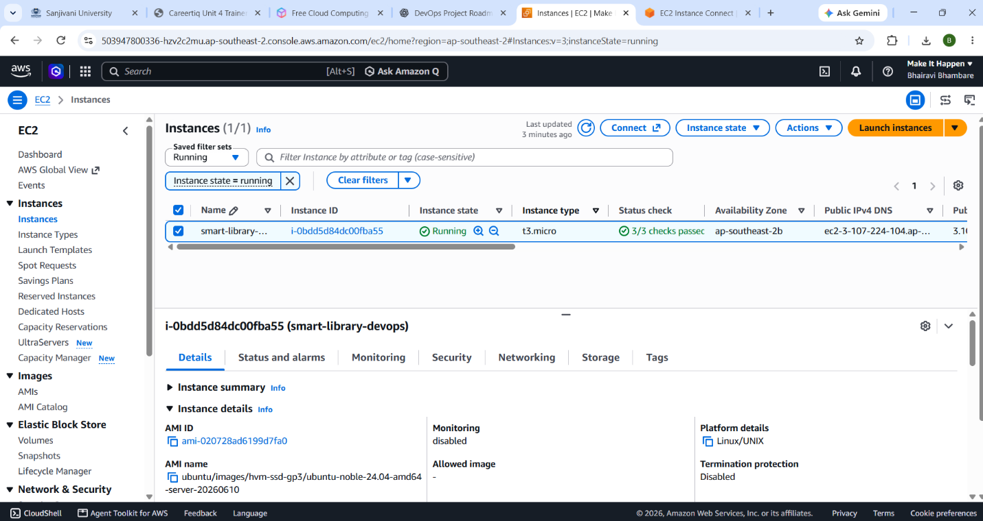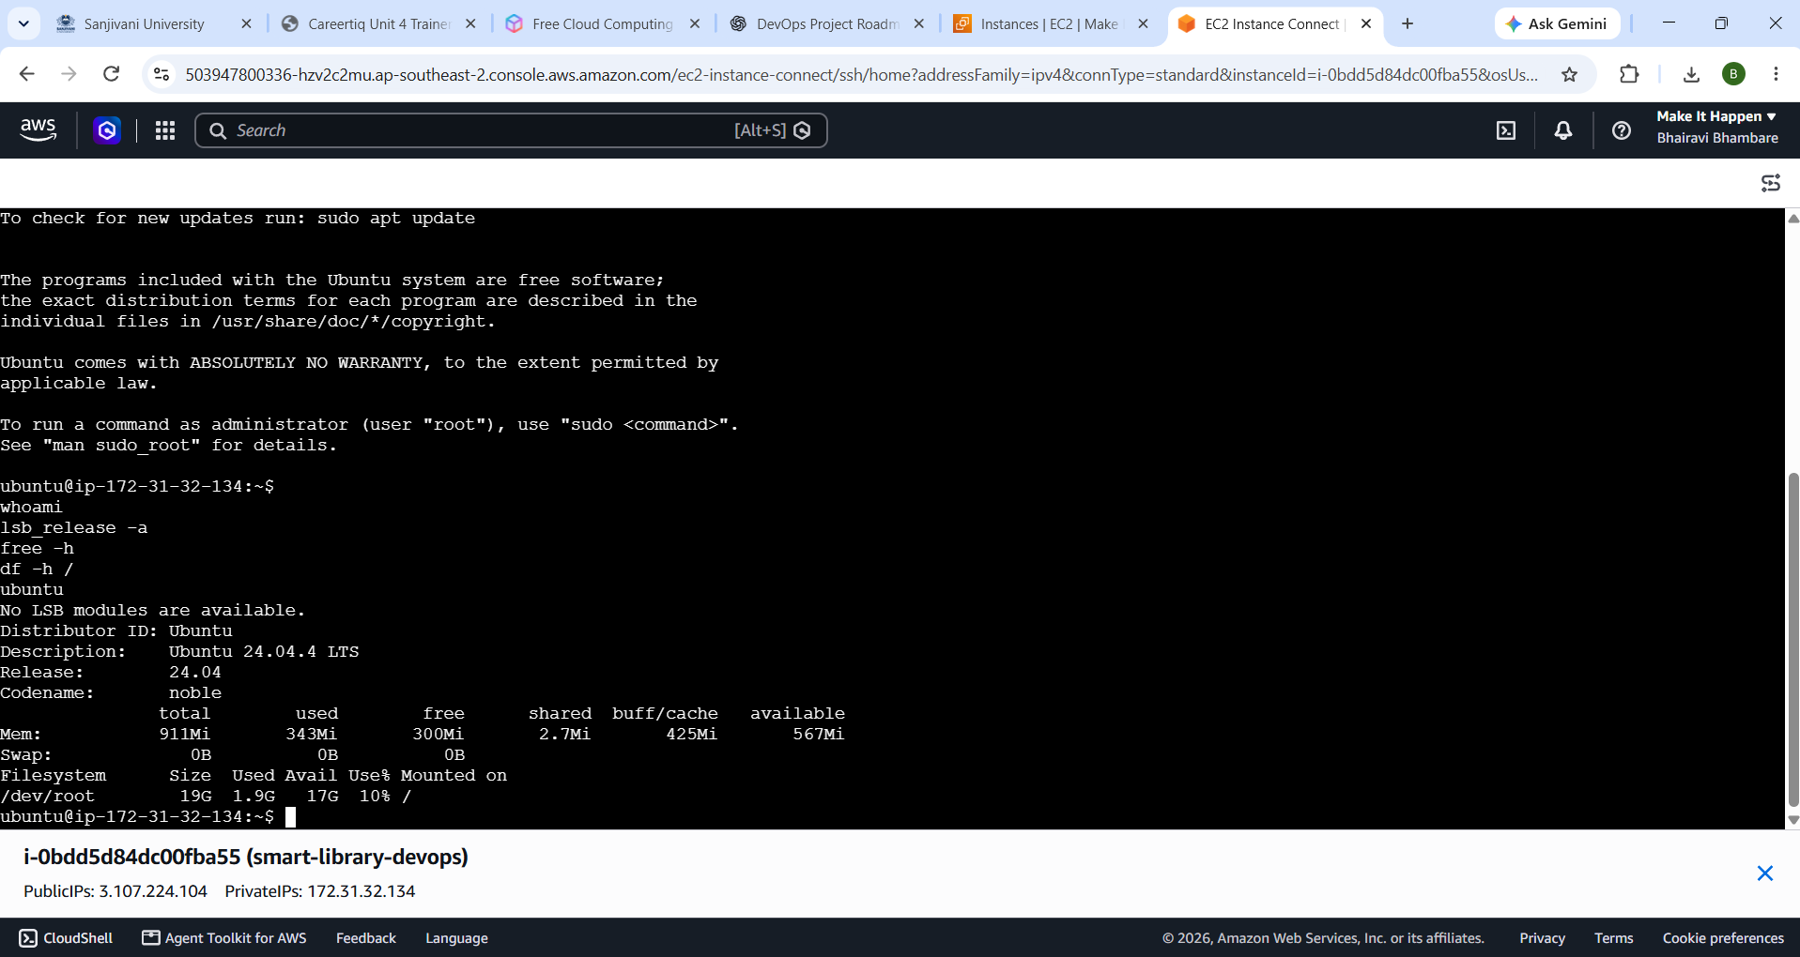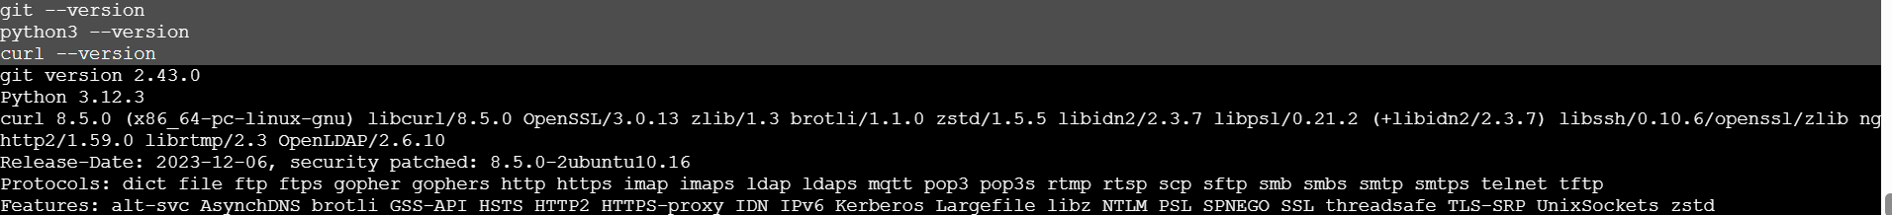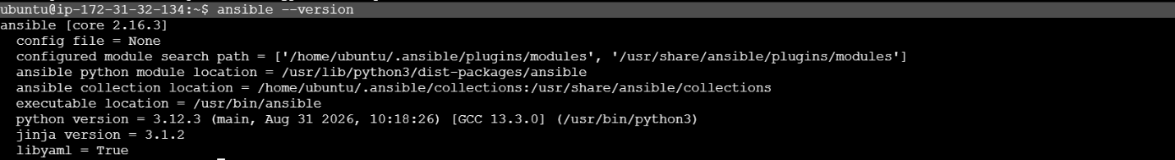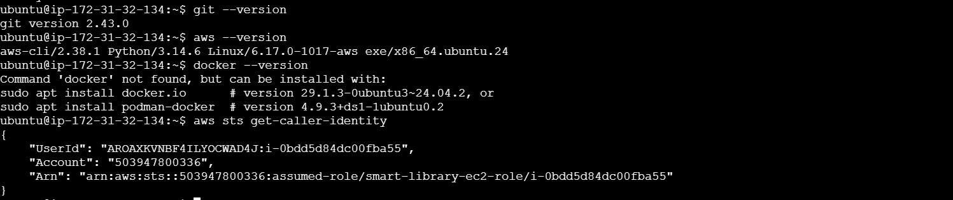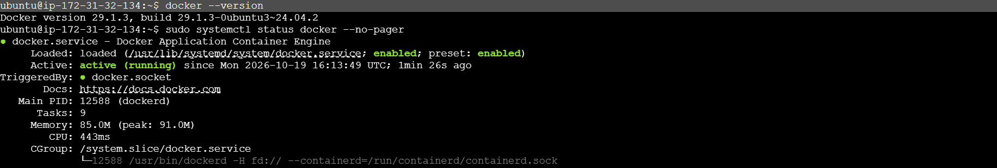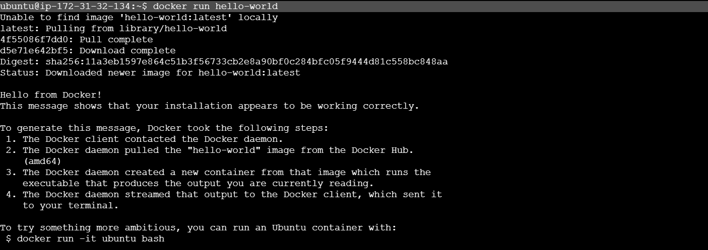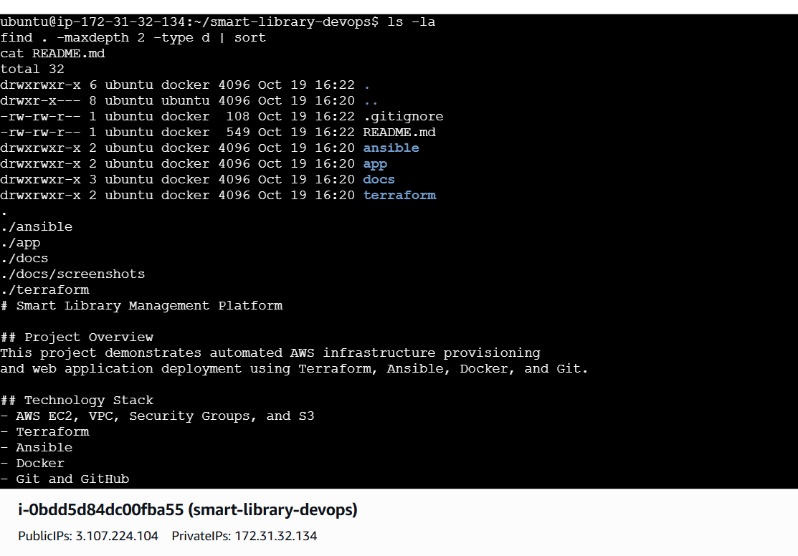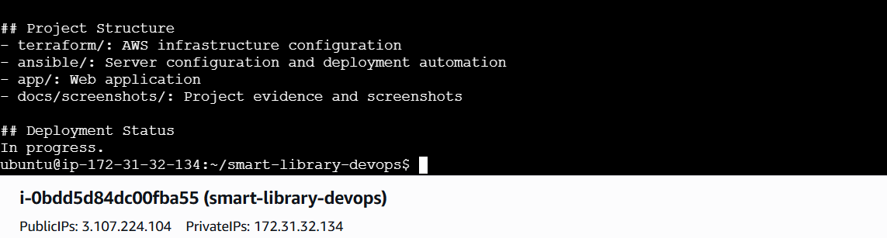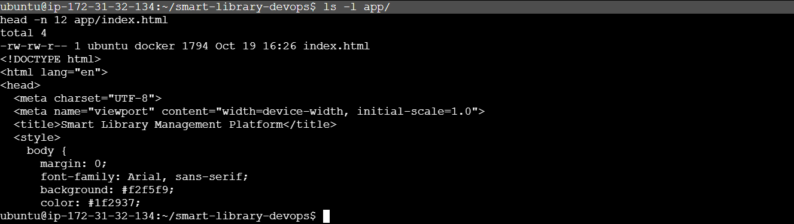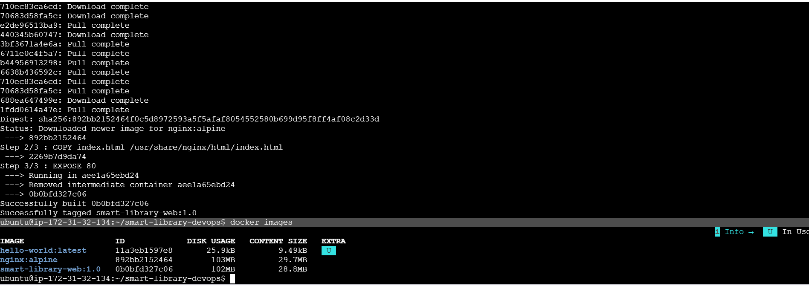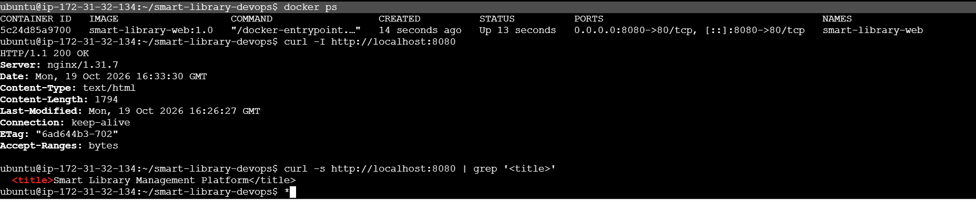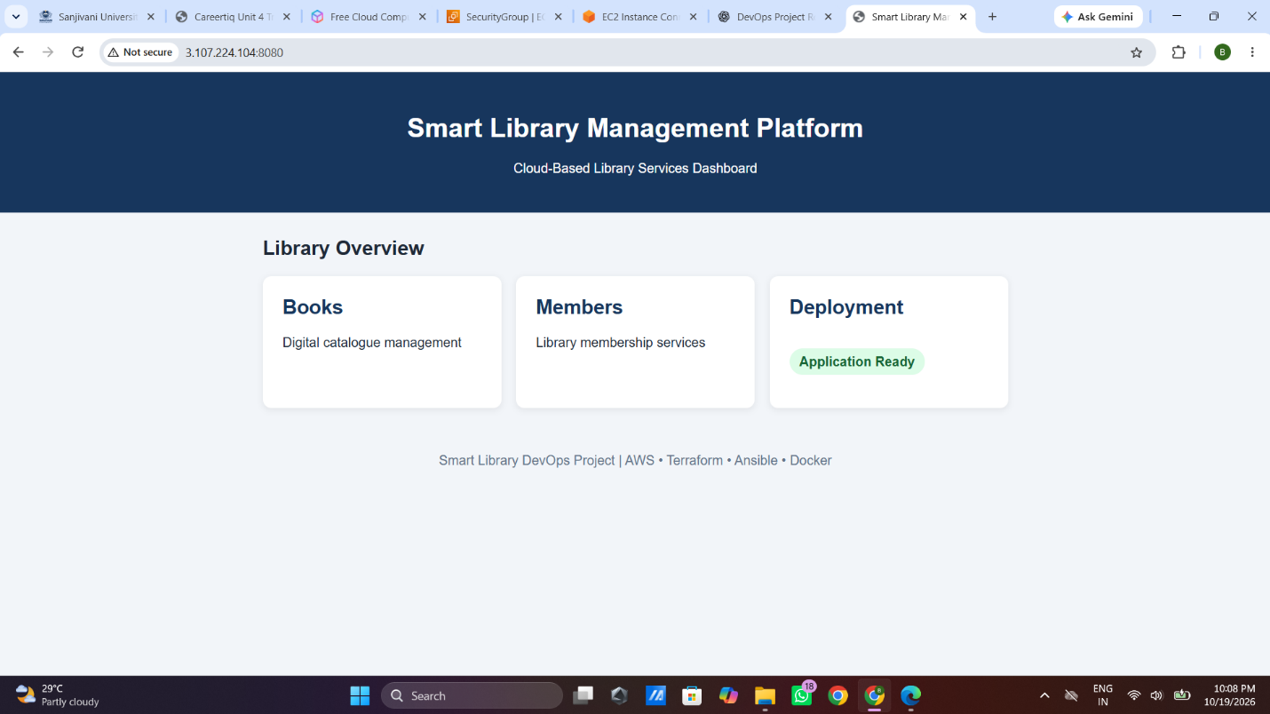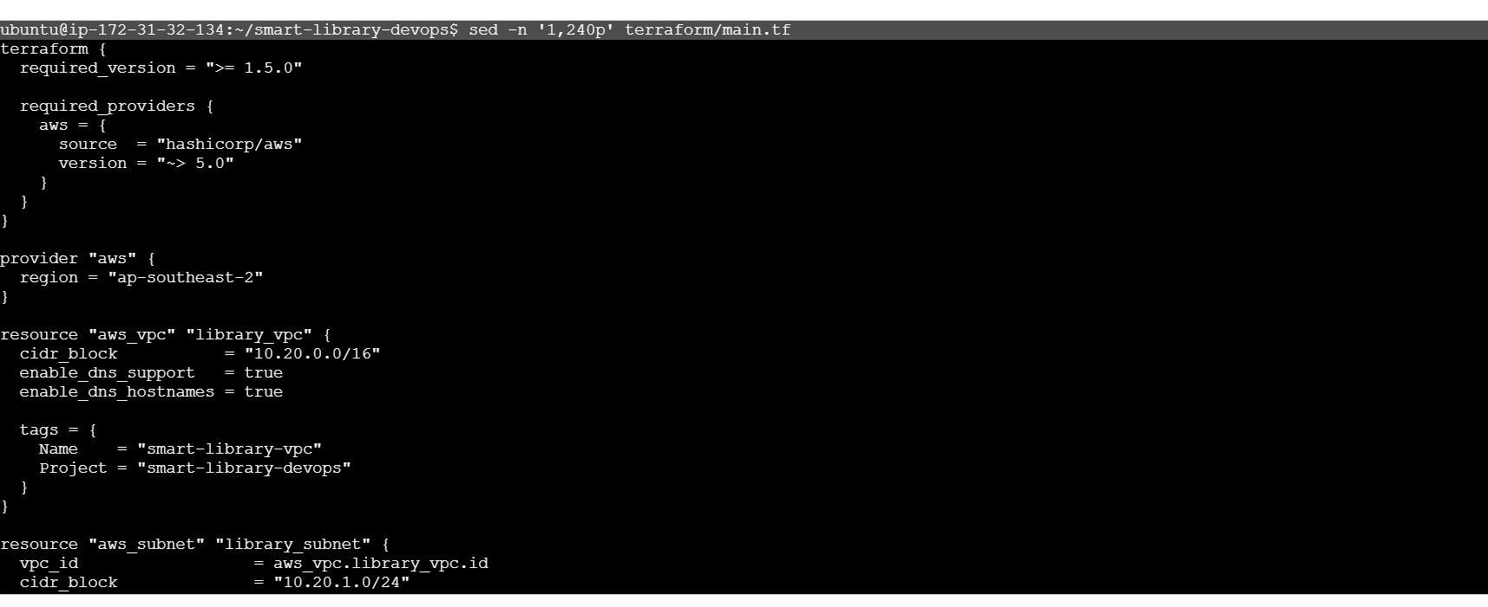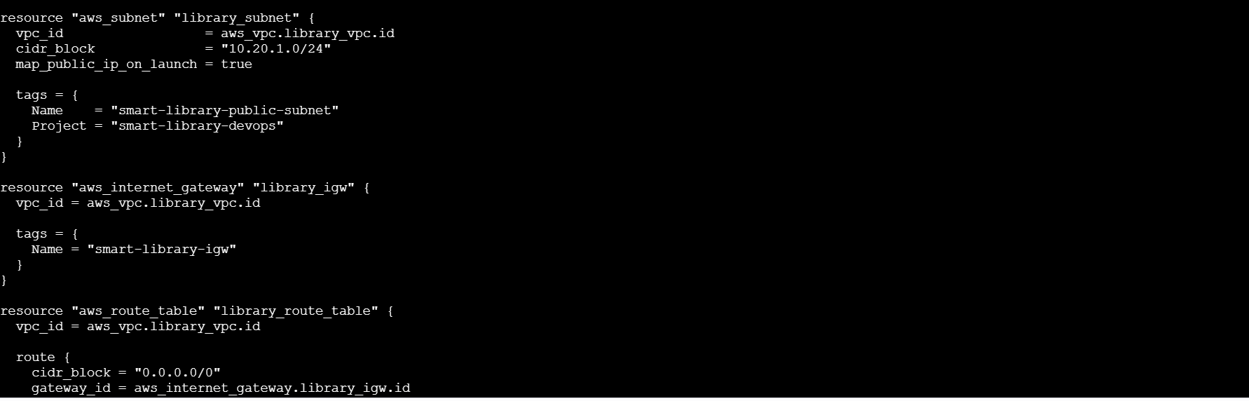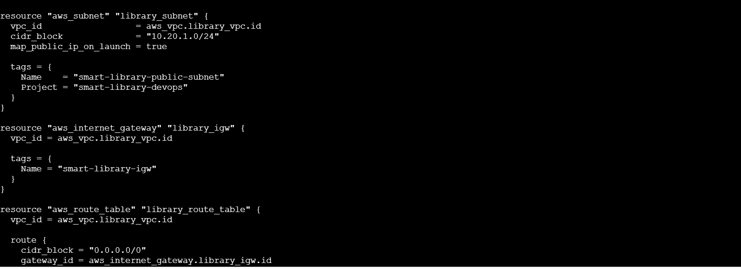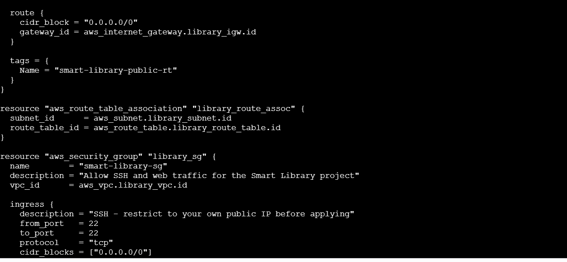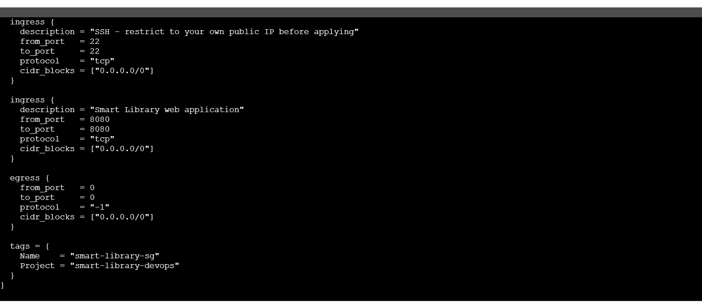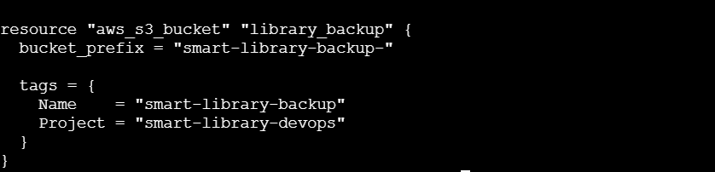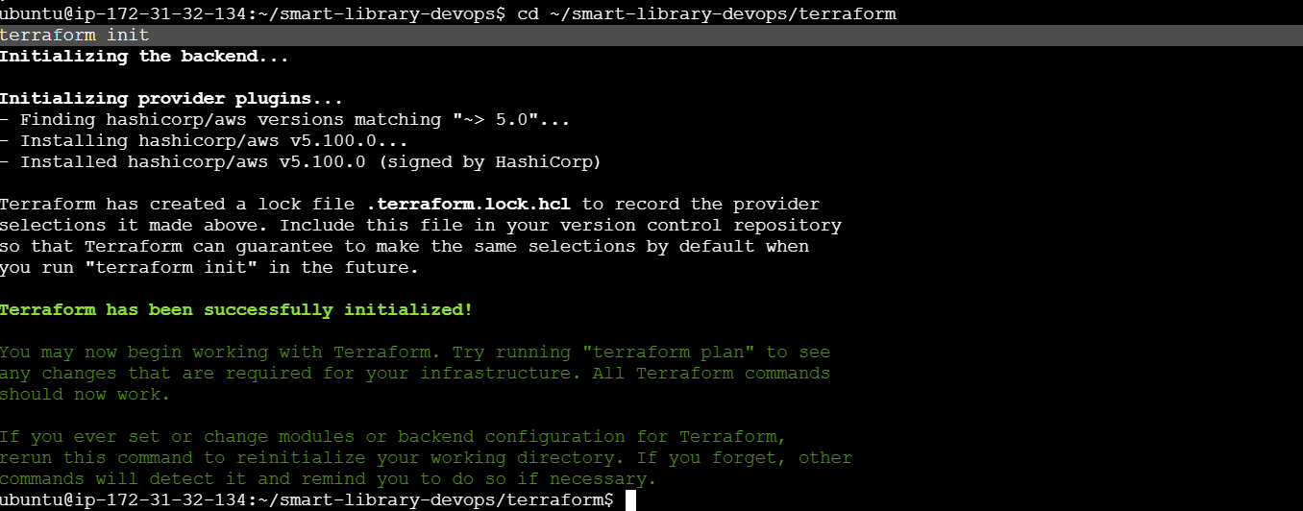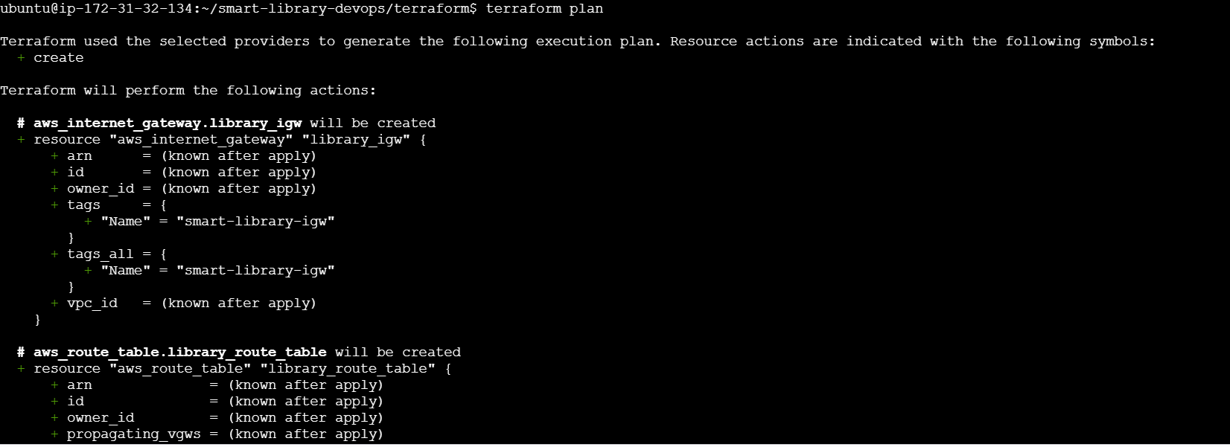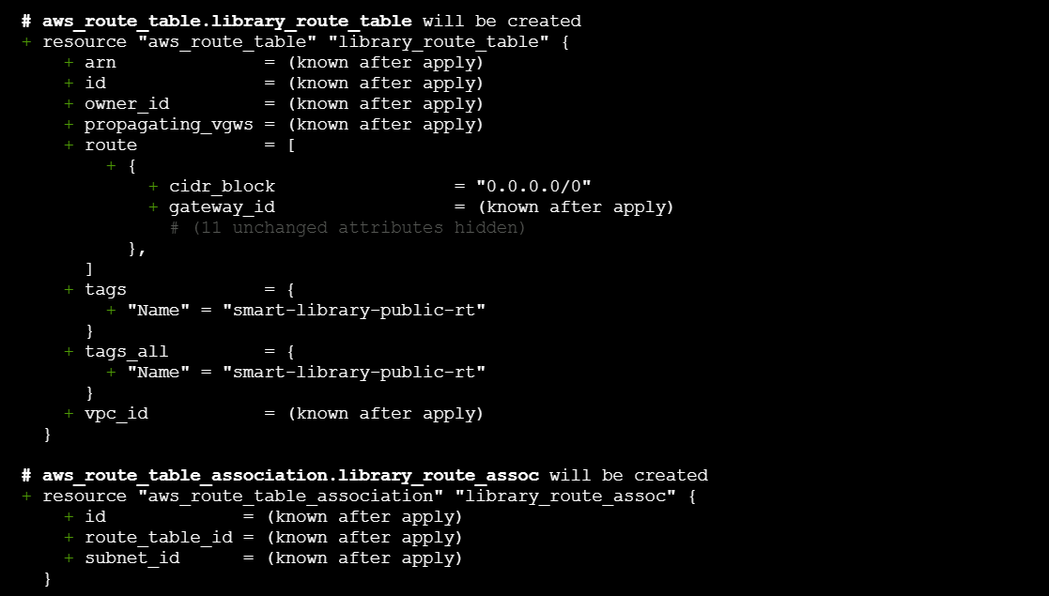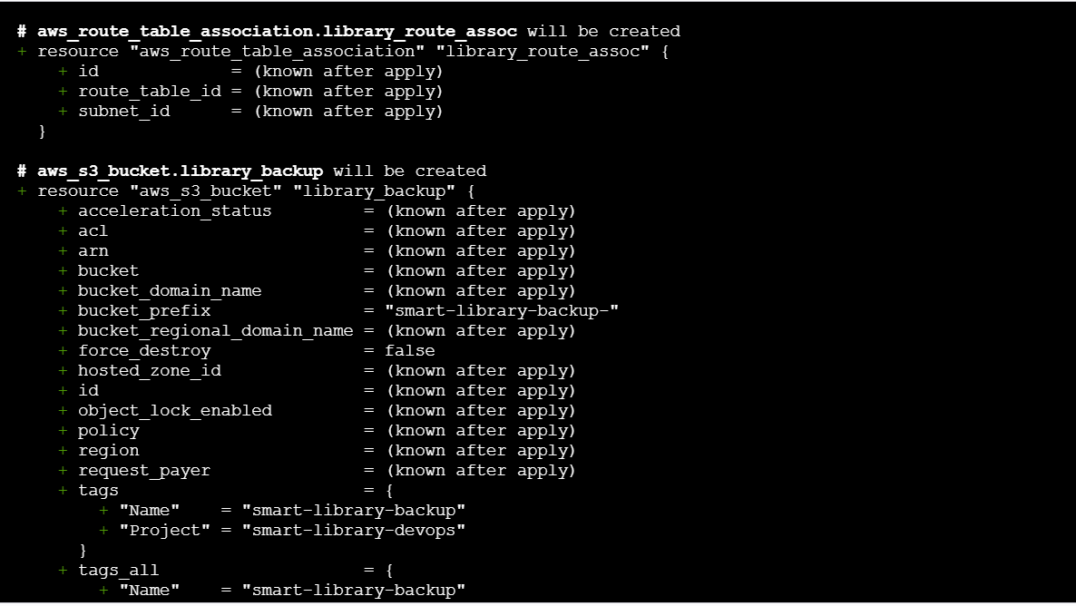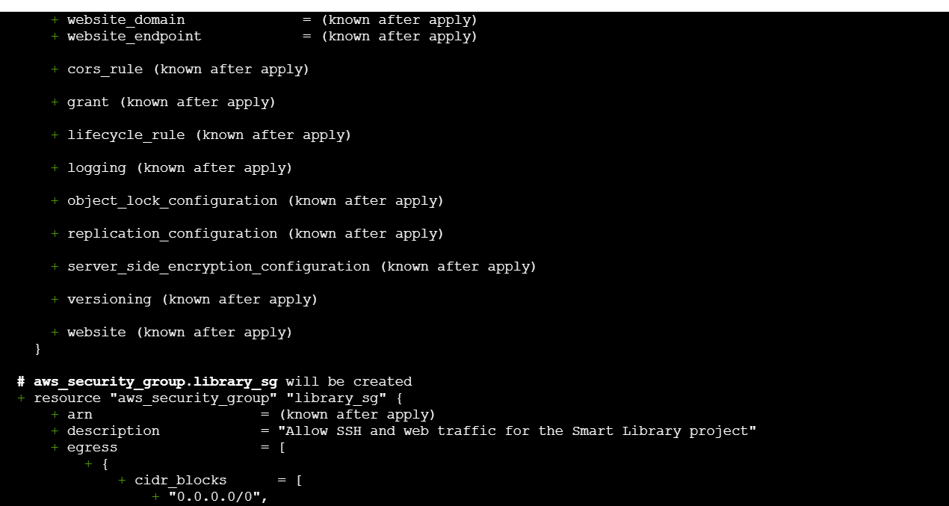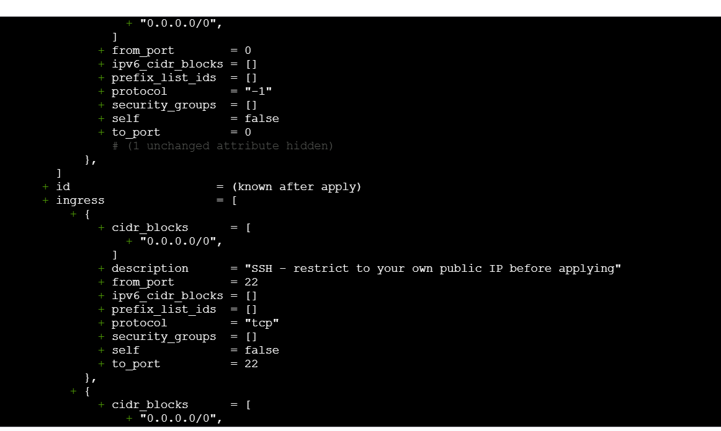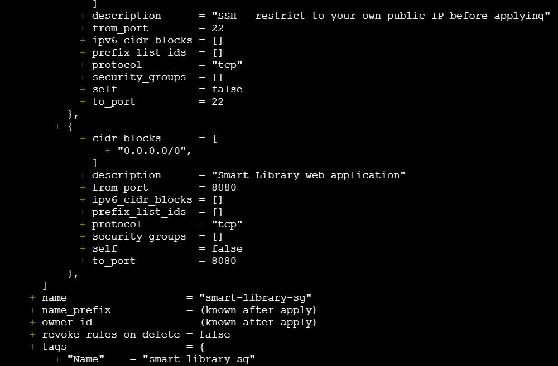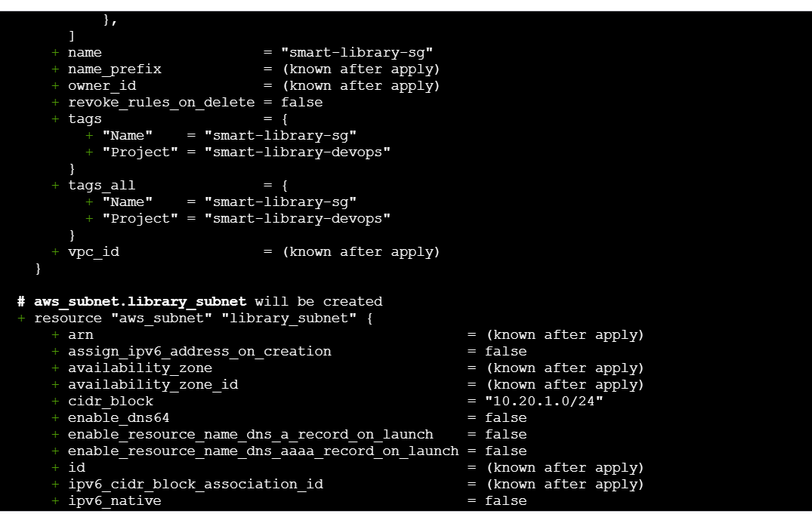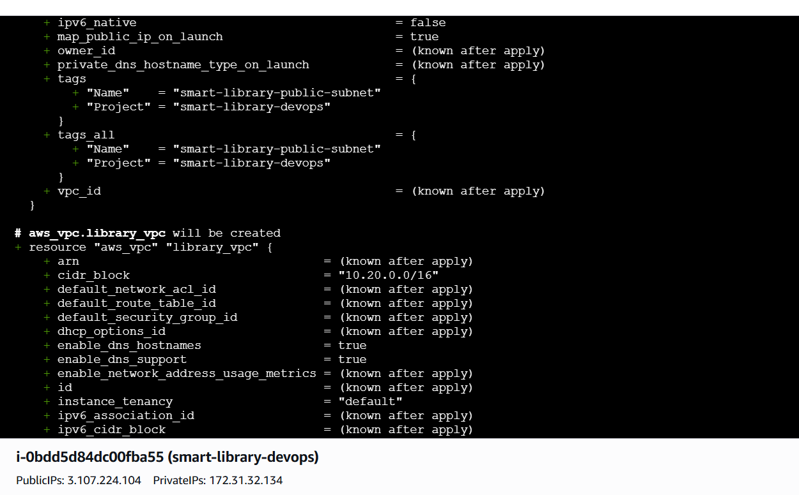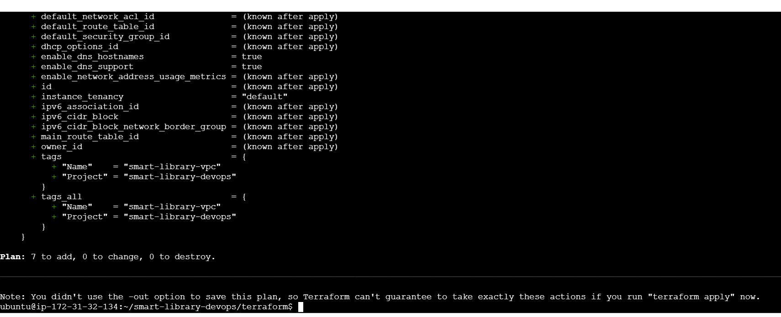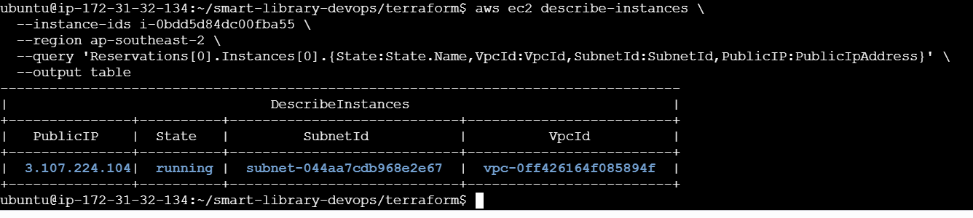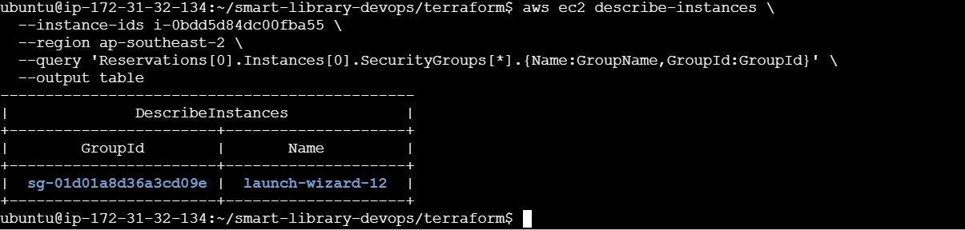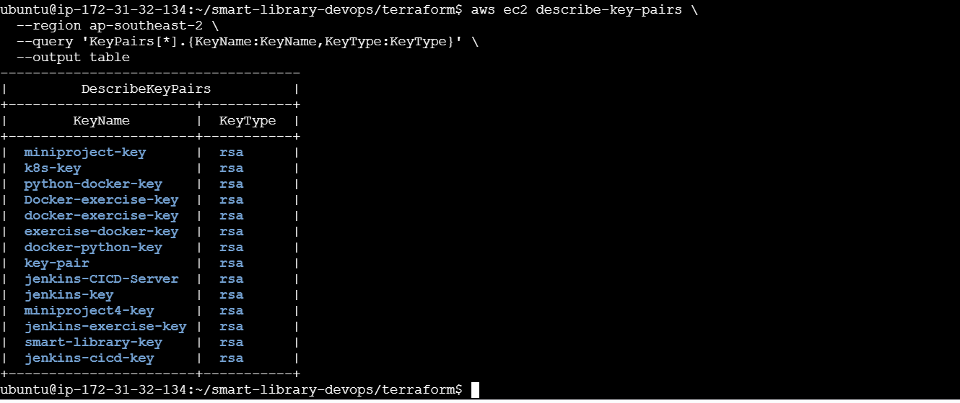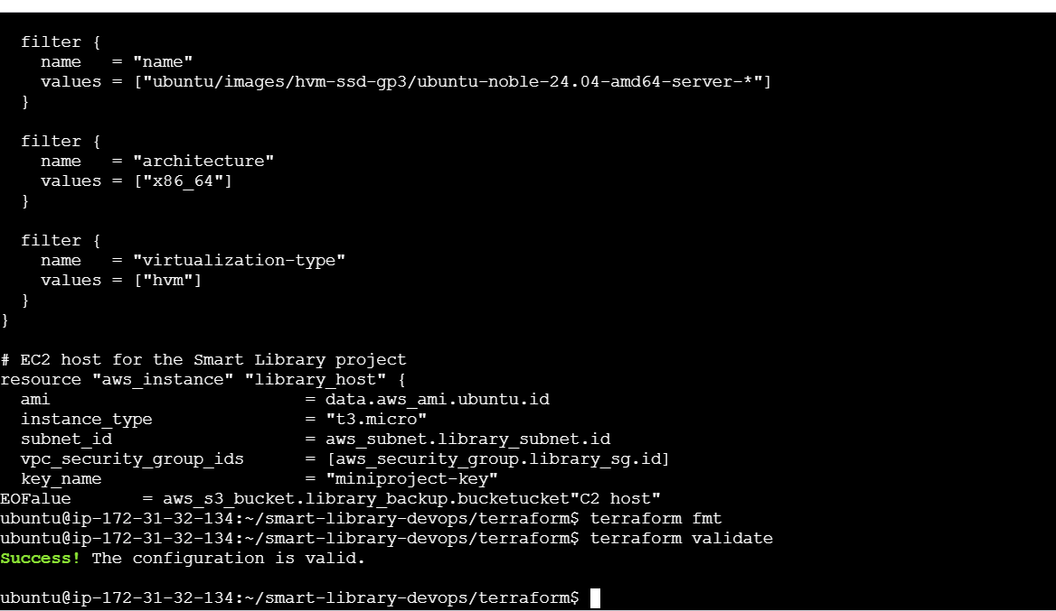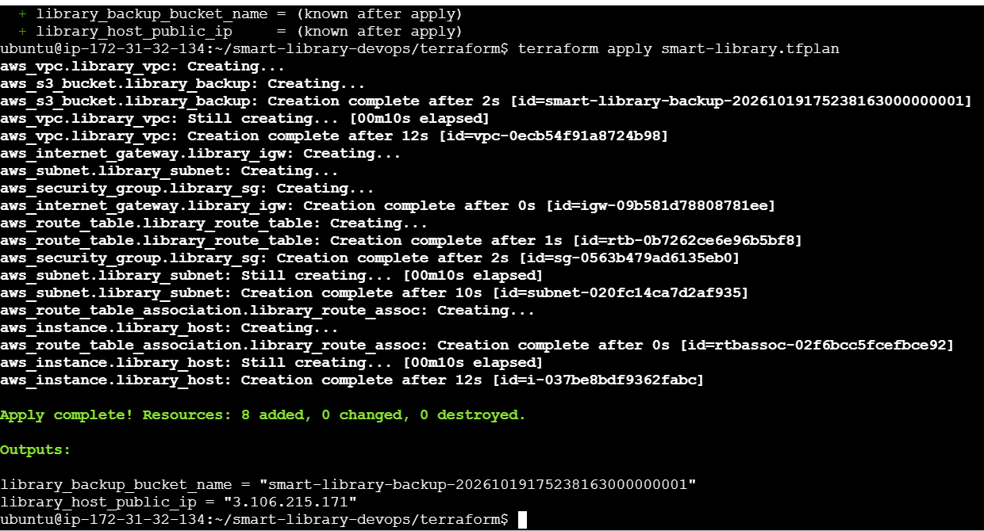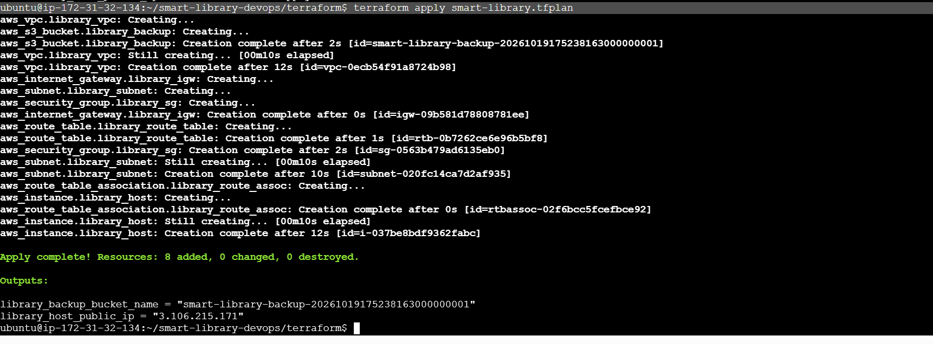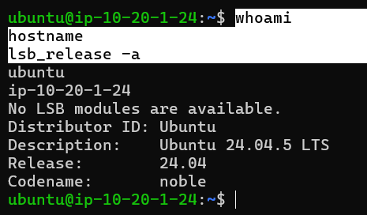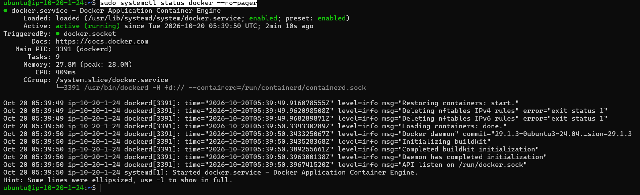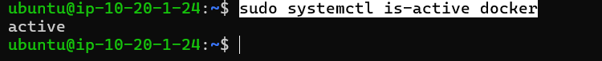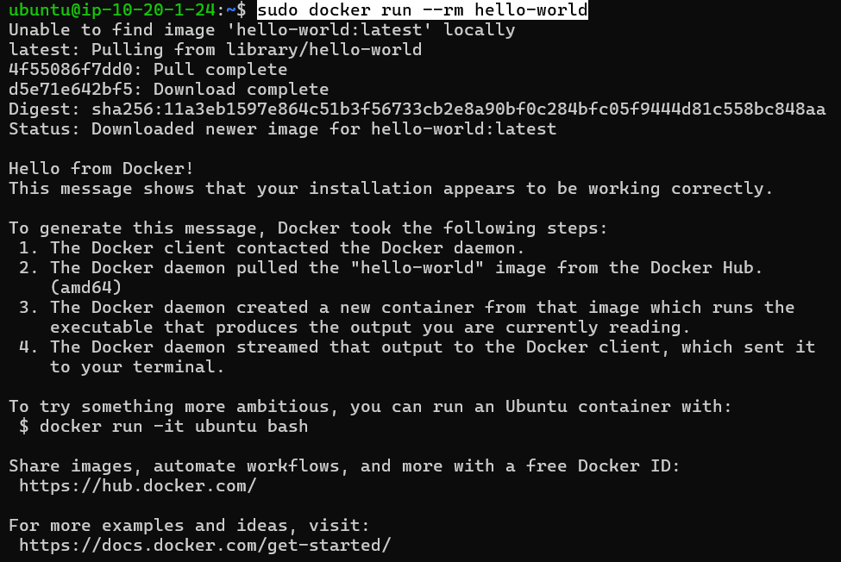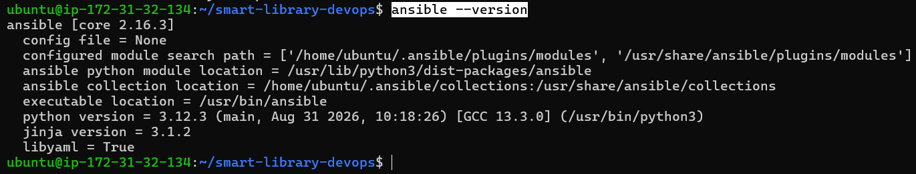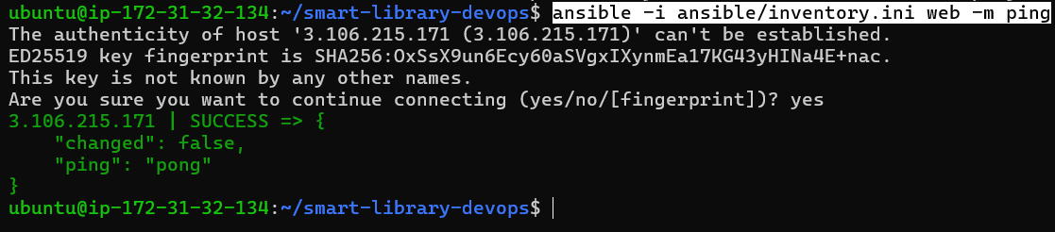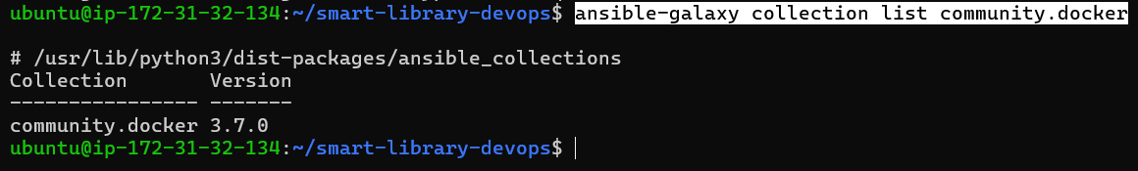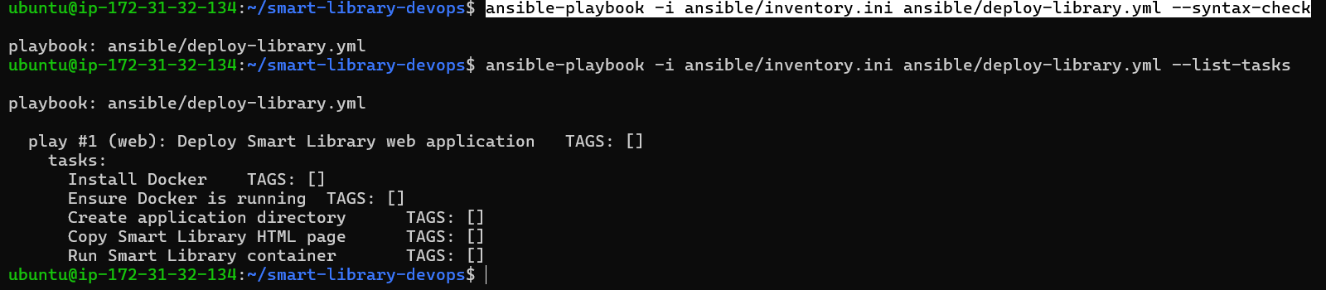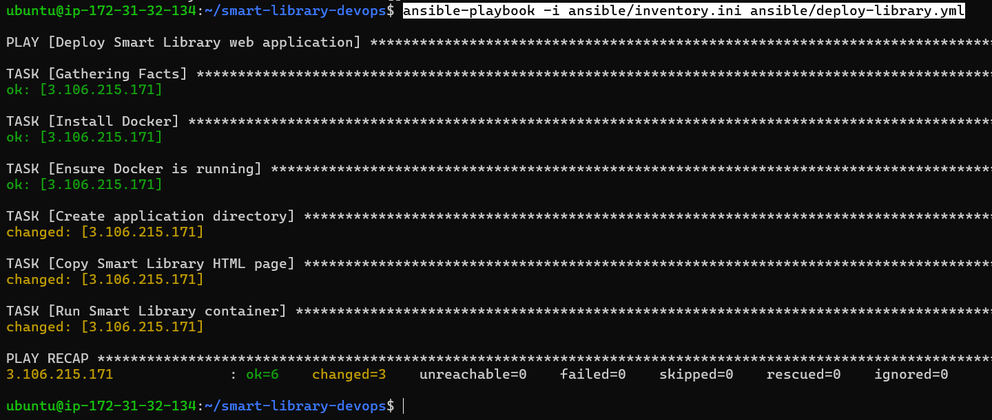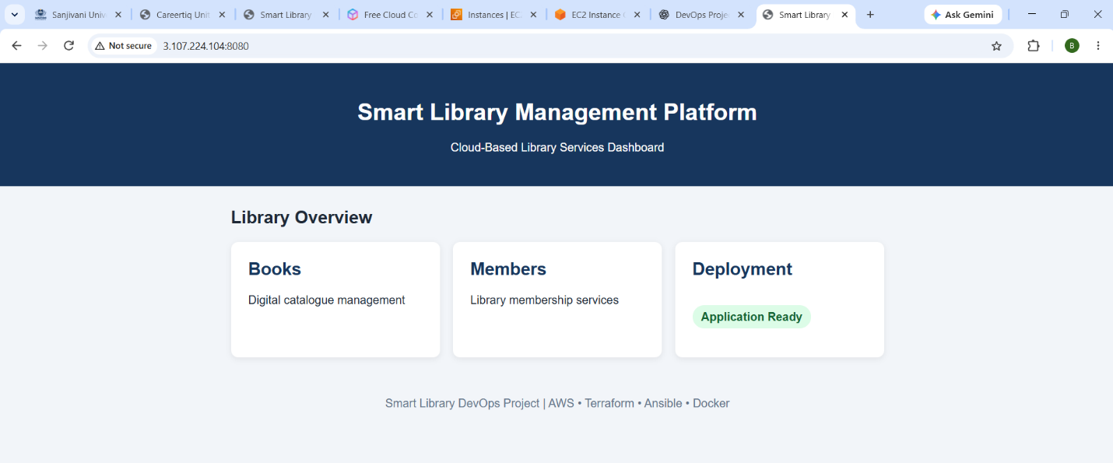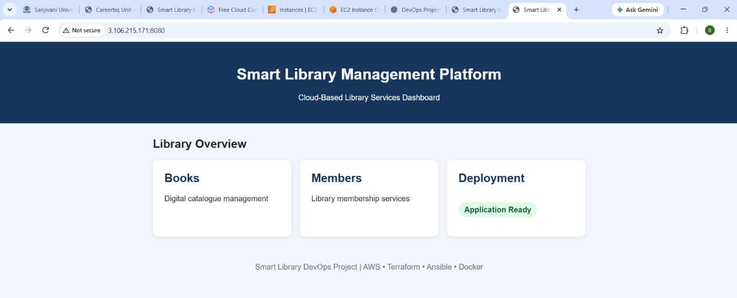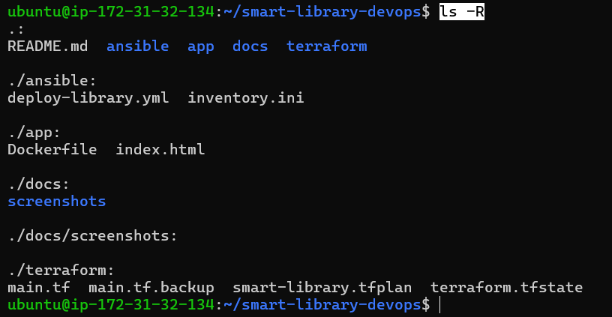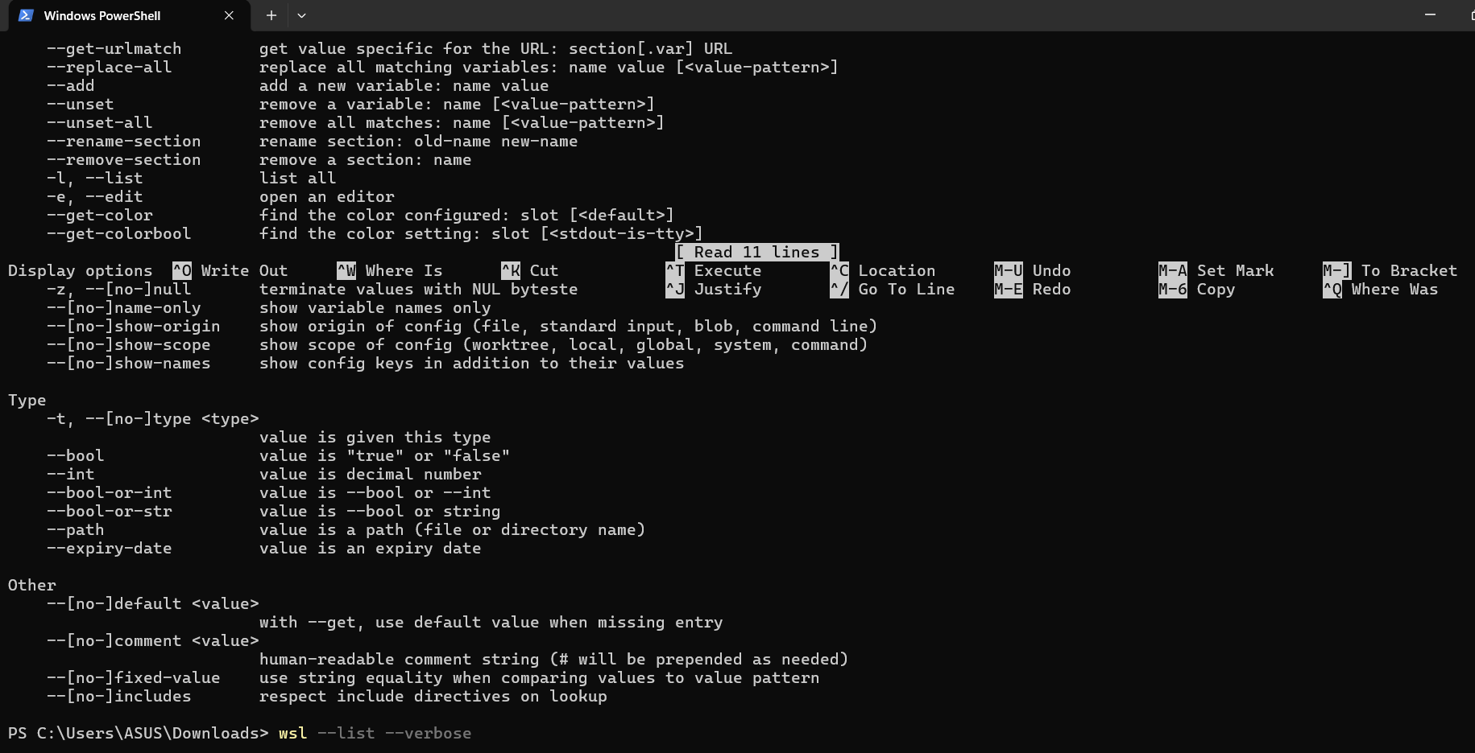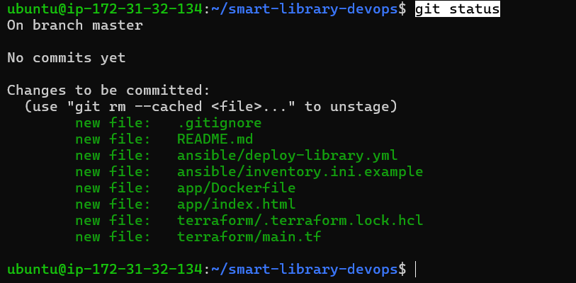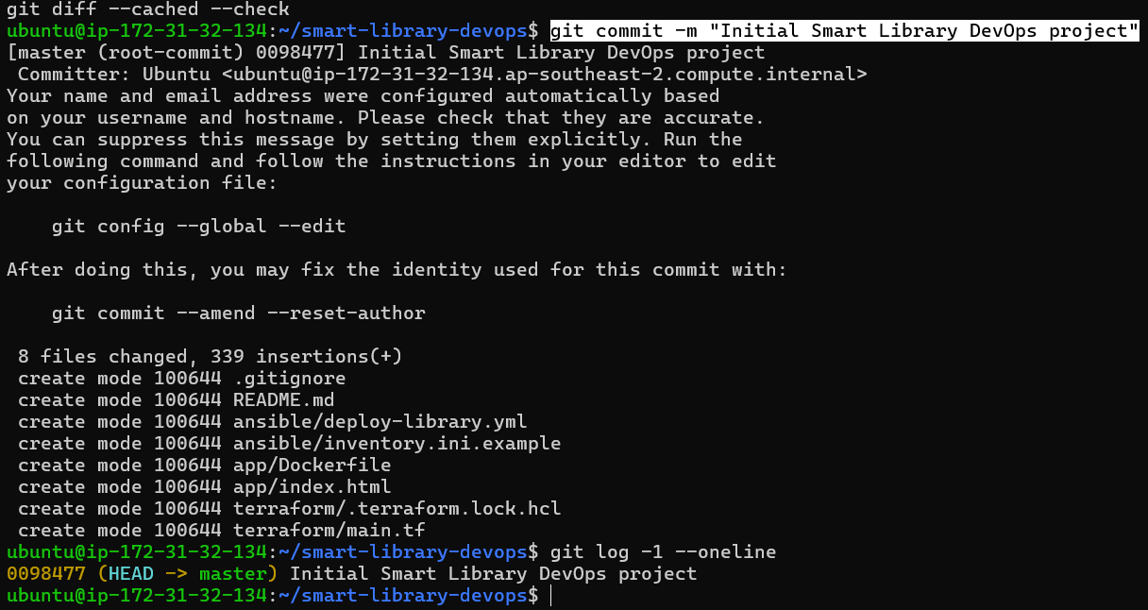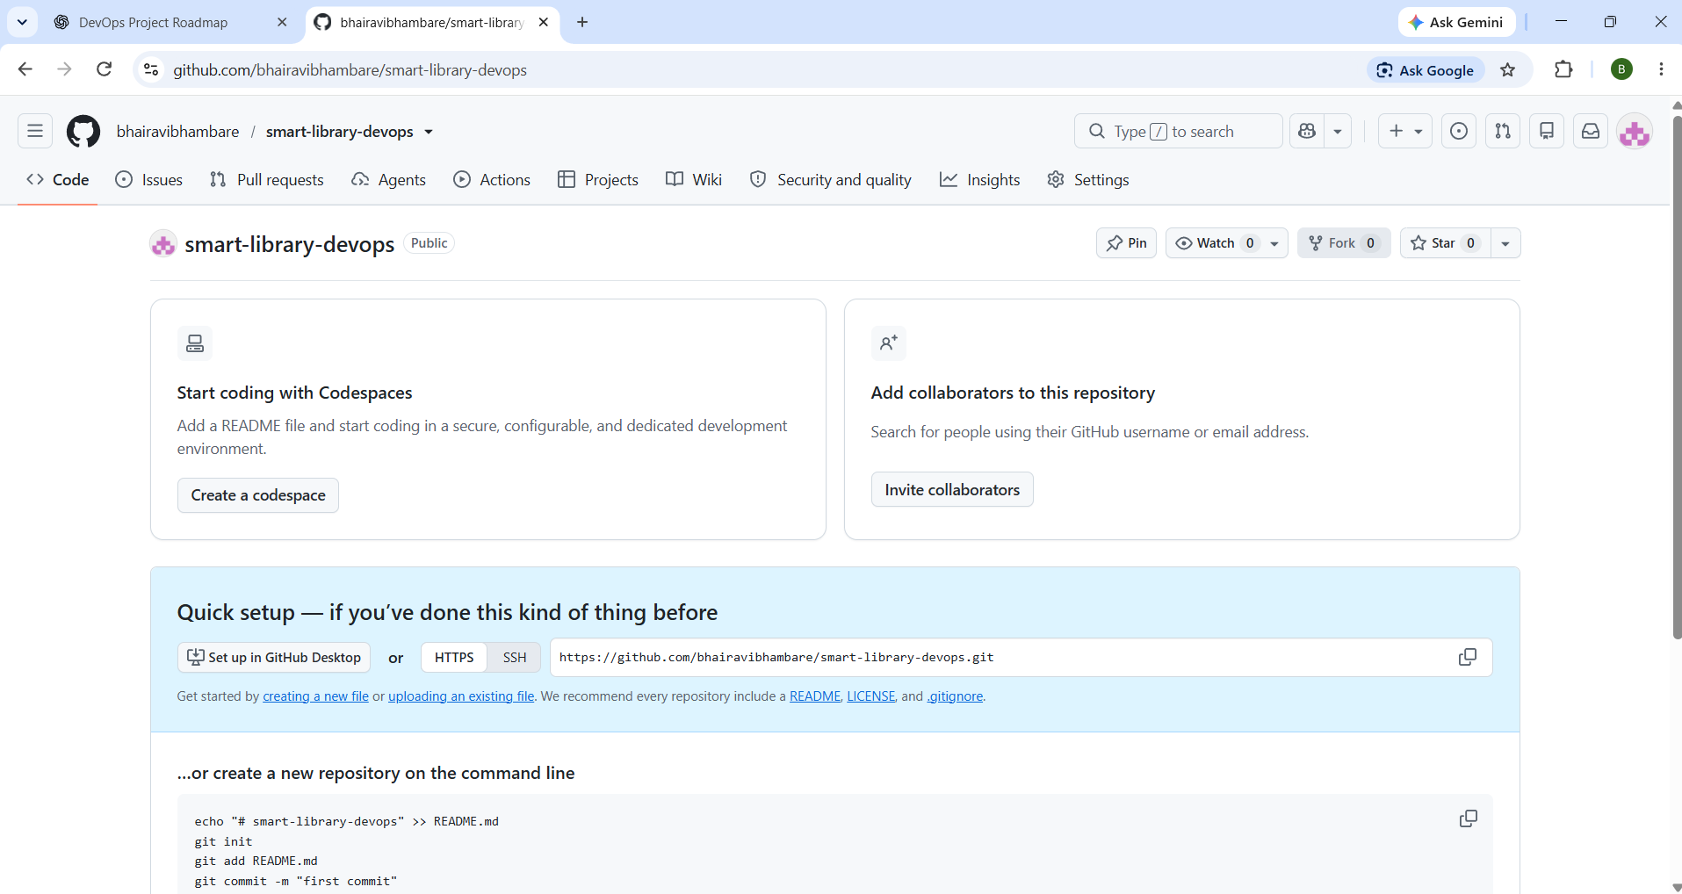
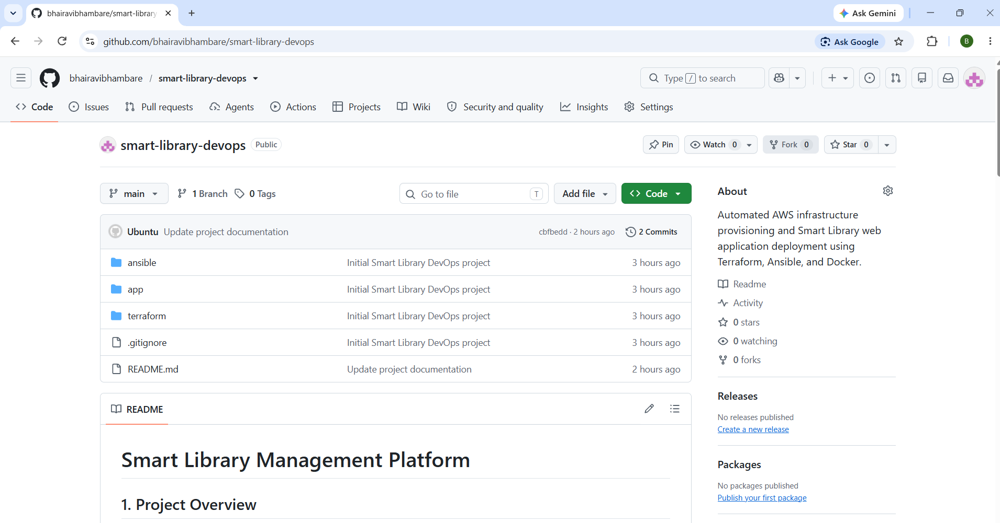
7. Testing, Validation & Results
- Syntax & Tool Checks: Validated Terraform configuration files successfully using terraform validate.
- Connectivity Testing: Verified successful HTTP 200 responses and rendered UI dashboards via the EC2 public IP address on port 8080.
8. Challenges, Learnings & Conclusion
- Challenges: Managing dependencies across multiple DevOps tools (Terraform, Ansible, Docker) and ensuring proper network security group port mapping.
- Learnings: Emphasizes the significance of automated repeatable workflows, early configuration validation, and structured infrastructure pipelines.
- Conclusion: Successfully established a reproducible automated cloud deployment pipeline for the Smart Library Management Platform using AWS and DevOps practices.

